**Lab Manual for Computer Communication and Networking**

**Lab No. 7**

**Static Routing**

**BAHRIA UNIVERSITY KARACHI CAMPUS**

**Department of Software Engineering**

**COMPUTER COMMUNICATION & NETWORKING**

**LAB EXPERIMENT # 7**

Static Routing

**OBJECTIVE: -**

* This lab assignment helps in understanding how static routing can be configured on a router.

**THEORY: -**

Static routing occurs when you manually add routes in each router’s routing table. There are pros and cons to static routing, but that’s true for all routing processes. Static routing has the following benefits:

* There is no overhead on the router CPU, which means you, could possibly buy a cheaper router than you would use if you were using dynamic routing.
* It adds security because the administrator can choose to allow routing access to certain networks only.
* Static routing has the following disadvantages:
* The administrator must really understand the internetwork and how each router is connected to configure routes correctly.
* If a network is added to the internetwork, the administrator must add a route to it on all routers—by hand.
* It’s not feasible in large networks because maintaining it would be a full-time job.

**NETWORK TOPOLOGY: -**



**PROCEDURE AND OBSERVATION: -**

**Step01: Configuring static routing on router 1**

Router1(config)#interface GigabitEthernet0/0

Router1(config-if)#ip address 15.0.0.1 255.0.0.0

Router1(config-if)#no shut

Router1(config-if)#exit

Router1(config)#interface fa 0/0

Router1(config-if)#ip address 10.0.0.3 255.0.0.0

Router1(config-if)#no shut

Router1(config-if)#exit

Router1(config)#ip route 20.0.0.0 255.0.0.0 15.0.0.2 (IP route)

Router1# show ip route

The above given command inserts a static route into the routing table of router saying, if a packet having destination address of network 20.0.0.0/8 is received on any of the router interfaces then it should be routed to 15.0.0.2

**Step 02: Configuring static routing on router 2**

Router2(config)#interface GigabitEthernet0/0

Router2(config-if)#ip address 15.0.0.5 255.0.0.0

Router2(config-if)#no shut

Router2(config-if)#exit

Router2(config)#interface fa 0/0

Router2(config-if)#ip address 20.0.0.3 255.0.0.0

Router2(config-if)#no shut

Router2(config-if)#exit

Router2(config)#ip route 10.0.0.0 255.0.0.0 15.0.0.1 (IP route)

Router2# show ip route

The above given command inserts a static route into the routing table of router saying, if a packet having destination address of network 10.0.0.0/8 is received on any of the router interfaces then it should be routed to 15.0.0.1

**Step03: Verify the route by pinging from Router 1 to Router 2**

Router2# ping 20.0.0.2

Router1# ping 10.0.0.2

**Step04: Verify the route by pinging from PC 1 to PC3**

C:\> ping 10.0.0.1 (from PC 1)

C:\> ping 20.0.0.2 (from PC 3)

**QUESTIONS: -**

1. **Configure static route on the following network and show all necessary configuration steps for each router.**



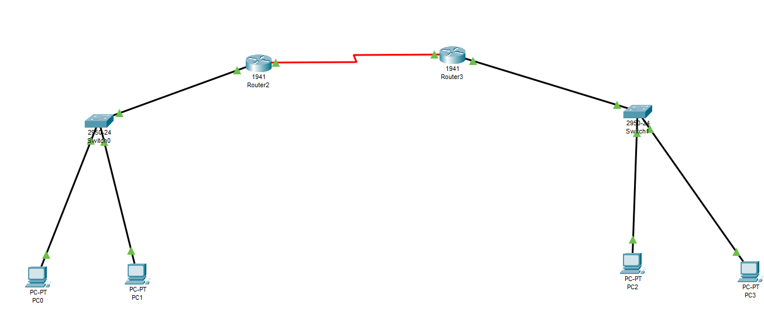

**Router 0:**

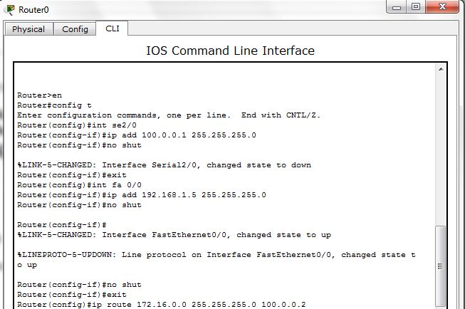

**Router 1:**

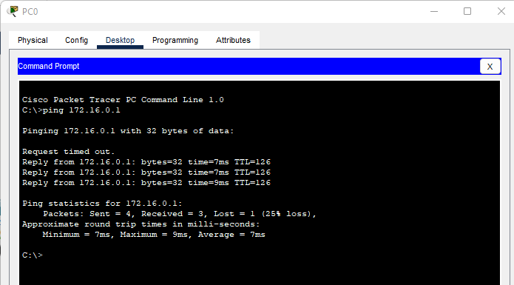

1. **Configure static route on the following network and show all necessary configuration steps for each router.**



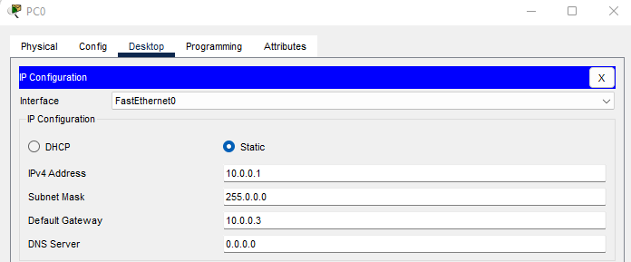

**Router 0**

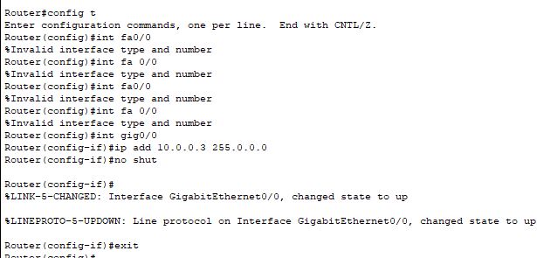

**Router 2**

**Router 0**

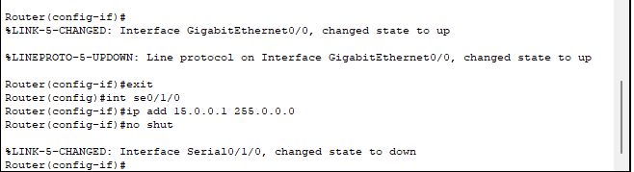

**Router 2**

**Router 1**

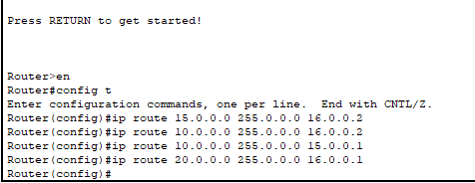

**Ping**

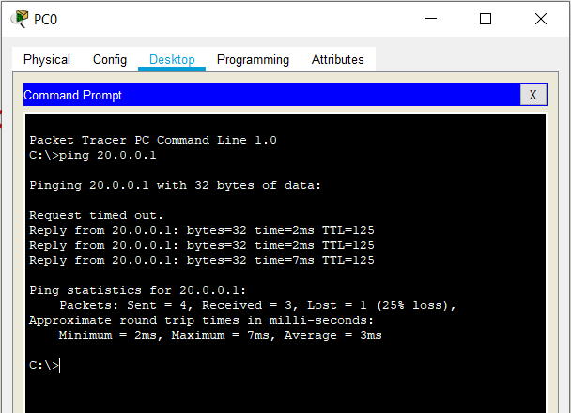

**TIME BOXING:**

|  |  |  |
| --- | --- | --- |
| **Activity Name** | **Activity Time** | **Total Time** |
| **Instruments Allocation + Setting up Lab** | 10 mints | 10 mints |
| **Walk through Theory & Tasks (Lecture)** | 60 mints | 60 mints |
| **Implementation & Practice time** | 90 mints | 80 mints |
| **Evaluation Time** | 20 mints | 20 mints |
|  | Total Duration | 180 mints |

**Teacher Signature**: ________________________

**Student Registration No**: ________________________